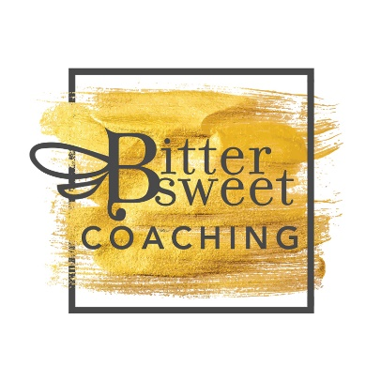
BitterSweet CoachingQuestions for Interview or Post
Thanks for agreeing to collaborate with me. You can choose an interview or post option.
Interview Option: Please answer the questions below in the first person for the interview option.
Post option: Write a post about a day in the life of whatever your niche is, e.g. fashion, beauty, wellness, entrepreneurial, and chronic illness. Posts can include parenting topics, top 10 guide to being a better parent, journey to recovery from a chronic illness, journey to becoming an entrepreneur (past employment and decisions leading to self-employment), wellness tips, or if there is something else that you would like to write, please let me know.
Include at least one quality photo of yourself (no selfies please). You can include up to five photos (high quality).
Required bio (write in 3rd person and limit to no more than 3-4 sentences):
Tell me about yourself and what motivated you to start blogging or your business?
1. What do you find most challenging about blogging or running your business?
2. Describe your experiences with some of the people you’ve met while blogging or doing business?
3. What networking do you do that helps your blogging or business?
4. How do you come up with material/content for your business or blog and keep ideas fresh?
5. What’s your strategy with your blog or business in general?
6. What’s the best thing a blogger can give to his readers or a business can give its customers?
7. What are some tips for people interesting in making money from blogging? What are some realistic expectations in regards to what can be made?
8. What has been your strategy for creating visibility to yourself and / or your blog?
9. What was the most challenging moment in your blog content development process or starting your business and why?
10. If someone was interested in blogging or starting a new business, what would be a few things you would suggest?
Required: Include link to your site and social media networks. Please use hyperlink in word document for social media handles.

